2.2 Limits (An Intuitive Approach) Worksheet

- Consider the following graph of the function . Determine each of the following limits.
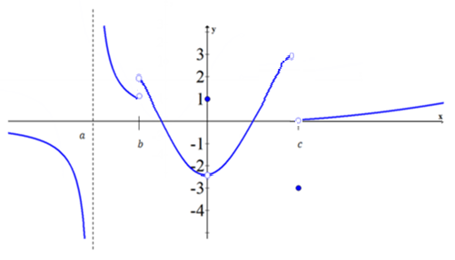

- Consider the following graph of the function . Determine each of the following limits.
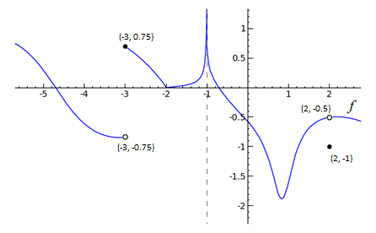

- Sketch the graph of an example of a function f that satisfies all of the given conditions:

